Decision, Analysis and Resolution (DAR) Guidelines Document

1. Guidelines for implementation of DAR 5

1.1 Select a Decision Team 5

1.2 Establish Evaluation Criteria 5

1.3 Identify solutions 5

1.4 select evaluation methods 6

1.4.1 Decision Tree Analysis 6

1.4.2 Open discussion, opinion, brainstorming 10

1.4.3 Weighted grid analyses (Pugh matrix) 10

1.4.4 Simulations 12

1.4.5 Analyses of solutions to similar problems 12

1.4.6 Validated risk calculations: 12

1.4.7 Delphi method 13

1.4.8 Nominal Group Assessment 15

1.5 evaluate solutions against established criteria 17

1.6 Select solutions and prepare evaluation report 17

# Guidelines for implementation of DAR

## Select a Decision Team

3-5 relevant stakeholders. Team members may include:

* Subject matter expert
* User departments
* Process owner(s)
* Users/clients (people affected by the decision)
* People required to implement the solution

## Establish Evaluation Criteria

* Use a variety of methods to establish criteria including flow charts, decision trees
* Select a manageable number of criteria; at least 3 criteria
* Tie the evaluation criteria directly to business and project needs

## Identify solutions

* Document alternatives and risks in on the DAR worksheet and store the data in a repository so that unacceptable options can be prevented and acceptable solutions can be applied
* A PICK chart may be a simple way to quickly remove outlier solutions



## select evaluation methods

Some principles for the use of various evaluation methods are summarized below. These are not to be interpreted as hard rules, rather a quick guide as to how to engage in these methods if chosen.

### Decision Tree Analysis

Decision trees provide a framework to quantify values of outcomes and probabilities of achieving them. A decision tree may be useful when narrowing down options and quantifying their outcomes if they were selected.

|  |
| --- |
| *Example:*  *There is significant potential business in the Europe region, however, there are market sensitivities towards a fully outsourced client servicing model. The client wants to have someone locally based to provide service. The orgaziation is faced with the possible options to deploy a Europe-based competent servicing manager, or continue business as usual from an offshore model.* |

**Step 1:**

Start at the left side of your page with a small box which reflects the decision that has to be made. From this box draw lines towards the right for each possible solution and write that solution along the line.

At the end of each line, consider the results. Draw a square for another decision point, or a circle if the result of that decision is uncertain. Challenge each solution and outcome and important draw out as many solutions and outcomes as possible. Now you have a sense of the range of possible outcomes of your decisions. A sample decision tree for this example is shown below:

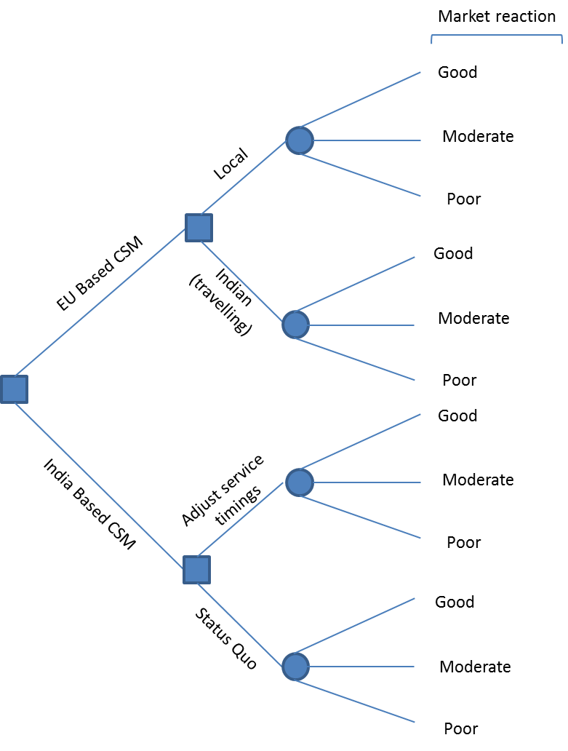

**Step 2:**

Now evaluate your decision tree. Assign a cash value or score to each possible outcome (i.e. if that outcome happened, what would the cash value be?) For each circle (uncertain point), estimate the probability of that outcome. Other analyses may be required separately to arrive at probabilities (i.e. gut feeling, objective evidence, discussions with customers, etc). Now our tree looks like this.

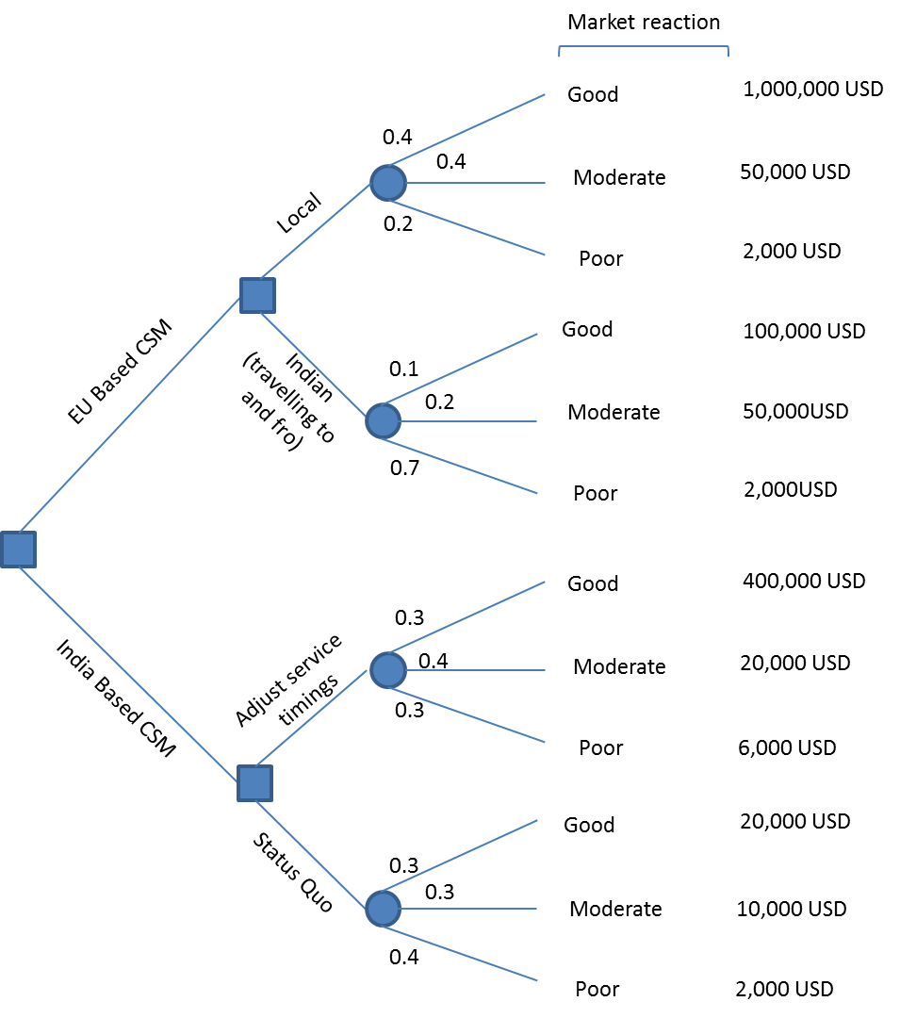

**Step 3:**

Calculate the tree outcome node values to help you arrive at the best decision. Start on the rightmost ones and move towards the left. To calculate the value of uncertain outcomes, multiply the outcome value by the probability. For instance, the nodal value for “local EU based CSM” will be:

|  |  |
| --- | --- |
| 0.4 (probability of good outcome) x 1,000,000 (value) | 400,000 |
| 0.4 (probability of moderate outcome) x 50,000 (value) | 20,000 |
| 0.2 (probability of poor outcome) x 2,000 (value) | 400 |
| **Total** | **420,400** |

Use the same concept for the remaining nodes and your tree will look like:

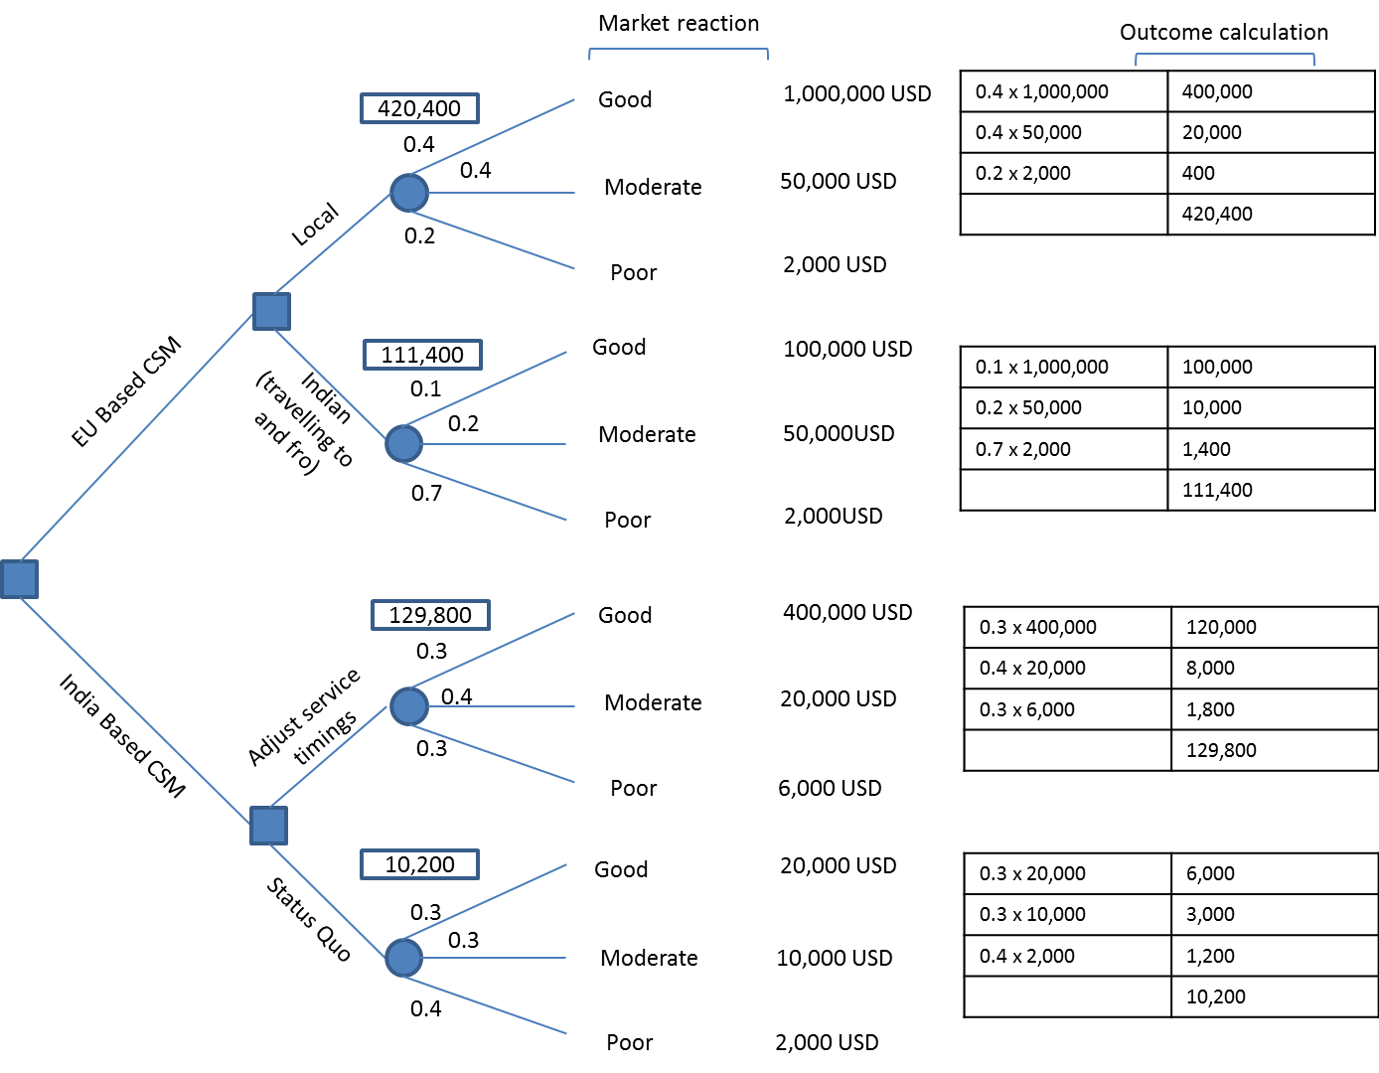

**Step 4:**

Calculate the value of decision nodes. The cost of each option along the decision line should be subtracted from the outcome value that you have calculated. This gives the benefit of that decision. The tree showing the cost of each decision and the net benefit is shown below.

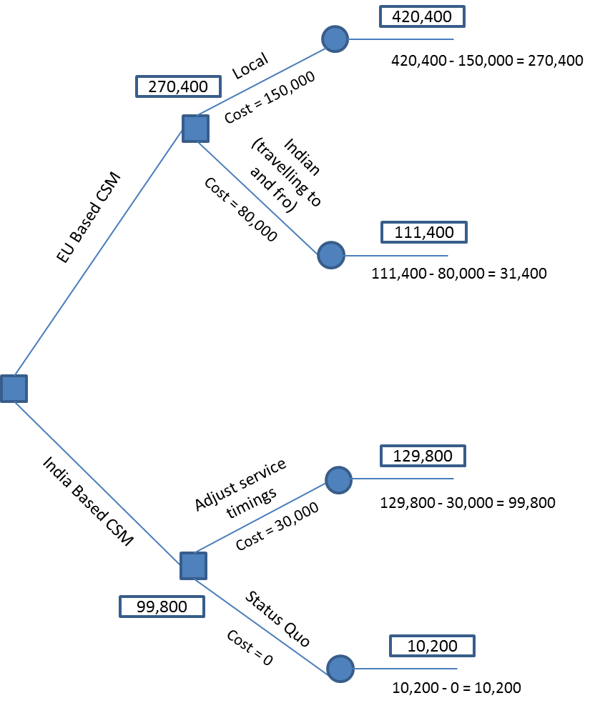

Result. The best option would be to place an EU based CSM with a net benefit of 270,400 vs. having an India based resource travel for the sake of being EU based. It would also be better to adjust the service offering timings in India to meet the client need than to maintain status quo.

(adapted from: <http://www.mindtools.com/dectree.html>)

### Open discussion, opinion, brainstorming

In general, these will be ad hoc, just in time meetings to gain advice/insight from chosen stakeholders. There may be a number of formats such as brainstorming at the meeting, pre-read followed by the actual meeting. In respect of time of all participants, an agenda and pre-read is mandatory. The meeting should be facilitated effectively such that decisions are reached. Sharing of information should be done as preparatory work. Minutes of meeting should be generated and a summary of the discussions should be captured clearly identifying the inputs and opinions from the various stakeholders.

### Weighted grid analyses (Pugh matrix)

A Pugh matrix may be used to objectively evaluate alternatives against a baseline relatively easily. For example the organization is using a particular process and there are 5 other potential processes and the organization wants to evaluate if any of the other ones are better. This can be completed by one person in consultation with experts for input. This may be a good reality check exercise before bringing in experts for formal decision taking.

Alternatively, it can be used when one solution is possible and you are deciding on the basis of multiple criteria. It can also be used in instances where there are many alternatives which are not themselves suitable, however, the best aspects of the solutions can be identified and a composite solution can be determined.

|  |
| --- |
| *Example:*  *We are deciding between 4 alternatives to an existing system and we want to know which one, if any, is better for us.* |

**Step 1:** decide our criteria that must be included. We choose price, installation time, ease of production and effort.

**Step 2:** draw the matrix, placing the alternatives across the top and the assessment criteria on the left.

|  |  |  |  |  |  |  |  |
| --- | --- | --- | --- | --- | --- | --- | --- |
|  |  | **Baseline** |  | **Solution A** | **Solution B** | **Solution C** | **Solution D** |
| **Criteria** |  |  |  |  |  |  |  |
| **Cost** |  | 0 |  |  |  |  |  |
| **Installation time** |  | 0 |  |  |  |  |  |
| **Ease** |  | 0 |  |  |  |  |  |
| **Effort** |  | 0 |  |  |  |  |  |

**Step 3:** For each solution, in relation to criteria 1 (cost), do we consider it better, same or worse than what we are currently using? Repeat this for the all solutions and criteria.

Our table looks like this now.

|  |  |  |  |  |  |  |  |
| --- | --- | --- | --- | --- | --- | --- | --- |
|  |  | **Baseline** |  | **Solution A** | **Solution B** | **Solution C** | **Solution D** |
| **Criteria** |  |  |  |  |  |  |  |
| **Cost** |  | 0 |  | +1 | -1 | 0 | +1 |
| **Installation time** |  | 0 |  | 0 | -1 | 0 | +1 |
| **Ease** |  | 0 |  | +1 | +1 | +1 | 0 |
| **Effort** |  | 0 |  | -1 | 0 | 0 | +1 |
| **Net score** |  |  |  | +1 | -1 | +1 | +3 |

Solutions A,C and D apparently look better than the existing system.

**Step 4:** Apply relative weighting for each criteria, for instance, cost gets a relative weighting of 2, while effort gets a 5. This indicates that effort is relatively more important than cost in our evaluation. All numbers to the right of the weighting are multiplied by the weighting.

|  |  |  |  |  |  |  |  |
| --- | --- | --- | --- | --- | --- | --- | --- |
|  |  | **Baseline** |  | **Solution A** | **Solution B** | **Solution C** | **Solution D** |
| **Criteria** |  |  |  |  |  |  |  |
| **Cost** |  | 0 | 2 | +2 | -2 | 0 | +2 |
| **Installation time** |  | 0 | 3 | 0 | -3 | 0 | +3 |
| **Ease** |  | 0 | 4 | +4 | +4 | +4 | 0 |
| **Effort** |  | 0 | 5 | -5 | 0 | 0 | +5 |
| **Net score** |  |  |  | +1 | -1 | +4 | +10 |

With weighting applied, we can see that solution D is clearly better. Solutions A and C, which were identical before weighting, are clearly differentiated now.

Different scales can be used to assign a score, for example:

+2, much better than

+1, better than

0, equal to

-1, worse than

-2, much worse than

Adapted from: <http://www.decision-making-confidence.com/pugh-matrix.html>

### Simulations

Simulations can be useful to pressure test possible solutions within a simulated delivery environment. Examples may include trial of a full capability version of a new software solution in a delivery setting to understand whether it can mesh with current organizational workflows and org structures. This is to be distinguished from a trial version of a software. The distinction lies in the fact that in a simulation, assumptions, parameters have to be clearly captured in order to make it applicable to the on-ground production scenario. Expected results should also be decided a priori(ahead of time) and results will be measured against this.This is done to avoid bias. A trial does not necessarily take these parameters and assumptions into account when implementing.

Another example may be taking the current WBS template used in production and form a small team to simulate the use of the WSB template in the development of an iPad application. The goal of the simulation may be to evaluate the applicability of the current template against a different deliverable. The simulation may run for a period of time, say several weeks, then an analysis of the actual performance of the template against expected performace would be conducted in order to facilitate decisions.

### Analyses of solutions to similar problems

This is simple analysis of similar risks and issues for trends and general resolutions and outcomes.

### Validated risk calculations:

A qualitative and quantitative risk analysis should be completed.

A qualitative risk analysis assesses the priority of identified risks using their relative probability of occurrence and the corresponding impact on project objectives if the risk occurs. Other factors such as time frame for response and organization’s risk tolerance with project constraints are also considered. A typical grid is shown below:

|  |  |  |  |  |  |
| --- | --- | --- | --- | --- | --- |
| **Evaluating impact of risk on major project objectives** | | | | | |
| **Project Objective** | **Very low (0.05)** | **Low (0.10)** | **Moderate (0.20)** | **High (0.40)** | **Veryhigh (0.80)** |
| **Cost** | Insignificant cost increase | <10% cost increase | 10-20% cost increase | 20-40% cost increase | >40% cost increase |
| **Time** | Insignificant time increase | <5% time increase | 5-10%time increase | 10-20% time increase | >20% time increase |
| **Scope** | Scope decrease barely noticeable | Minor areas of scope affected | Major areas of scope affected | Scope reduction unacceptable to sponsor | Project item is effectively useless |
| **Quality** | Quality degradation barely noticeable | Only very demanding applications are affected | Quality reduction requires sponsor approval | Quality reduction is unacceptable to sponsor | Project item is effectively useless |

An example of a quantitative analysis is expected monetary value (EMV) = risk probability x amount at stake

### Delphi method

The Delphi method is defined as a unique way of obtaining a consensus opinion by experts through a process of thesis, antithesis and eventual synthesis.

The steps followed in Delphi method.

**Step 1: Choose a Facilitator**

The first step is to choose the facilitator. It is useful to have someone that is familiar with research and data collection.

**Step 2: Identify Your Experts**

The Delphi technique relies on a panel of experts. This panel may be the project team, including the customer, or other experts from within the organisation or industry. An expert is "any individual with relevant knowledge and experience of a particular topic."

**Step 3: Define the Problem**

What is the problem or issue the individual is seeking to understand? The experts need to understand exactly what they are commenting on, so ensure you provide a clear and comprehensive definition.

**Step 4: Round One Questions**

Ask general questions to gain a broad understanding of the views of the experts about future events. The questions may go out in the form of questionnaires, surveys or face to face meetings. Collated and summarise the responses removing any irrelevant content and look for common viewpoints.

**Step 5: Round Two Questions**

Based on the answers to the first questions, these questions should go deeper into the topic to clarify specific issues. These questions may also go out in the form of questionnaires, surveys or face to face meeting. Again, collate and summarise the results removing any irrelevant content and look for the common ground. Remember, we are looking to build consensus.

**Step 6: Round Three Questions**

The final questionnaire aims to focus on supporting decision making. What is it the experts are all agreed on?(You may wish to have more than three rounds of questioning to reach a closer consensus.)

**Step 7: Act on Your Findings**

After this round of questions the experts will have, we hope, reached a consensus and will have a view of the future events. Analyse the findings and put plans in place to deal with future risks and opportunities to the project.

### Nominal Group Assessment

Nominal group techniques use a structured group which is best suited for identifying or prioritizing needs or evaluating options. The meeting should deal with a single question.

Some of the advantages and disadvantages are listed below:

|  |  |
| --- | --- |
| **Advantages** | **Dis advantages** |
| If well-organized in advance, a heterogeneous group can move toward definite group conclusions; the ideas belong tothe entire group. | May be extremely difficult to implement with large audiences unless advance preparation has taken place to train group facilitators and divide participants into groups of 6-10 members. |
| Can be used to expand the Information obtained from other sources, or can be used to generate a more specific survey. | May not be a sufficient source of data in itself; may require follow-up survey, observations, or documentary analysis. |
| Generates many ideas in a Short period of time; allows for a füll ränge of individual thoughts and concerns. | May be some overlap of ideas due to unclear wording or inadequate group discussion. |
| Motivates all participants to get involved because they sense they are personally affected; Can have polftical benefits. | Can give participants a taste of power that cannot be acted on. |
| Obtains in put from people of different backgrounds, experiences, and ages-taps into expertise that might otherwise not be used. | Knowledgeable individuals selected to participate may not represent all Community subgroups. |
| Gives all participants an equal opportunity to express opinions and ideas in a non-threatening setting. Separates generation of ideas frorn evaluation of ideas. | Assertive Personalities may dominate unless leadership skills are exercised. |
| Gives participants a voice in project decisions, and an opportunity to participate in and contribute to the project. |  |
| Stimulates creative thinking and effective dialogue, | Inappropriate technique forroutine rneetings, bargaining, negotiation, or coordination. |
| Allows for clarification of ideas; can be a sounding board | Requires a skilled leader, and can be time-consuming. |
| Identifies priorities on problem issues. | Process may appear rigid if group leader does not show flexibility-encourage agenda building, and show respectfor all ideas and concerns. |

**Step 1:** the assessment question is read and participantsanonmymously provide their written comment on cards.

**Step 2:** All cards are turned in to the leader, who writes it onto a flipchart, without discussion, revision or screening. This is done until all responses are turned in.

**Step 3:** group discussion is lead with each idea read aloud followed by an opportunity to clarify, agree or disagree. The intent is not to persuade

**Step 4:** Each participant selects 5 items that he/she feels is most important and ranks them in terms of importance to them. The leader collects the results and shares the results of the voting.

The output is a prioritized list of options, ideas, etc upon which the group can take action.

## evaluate solutions against established criteria

* Project manager facilitates team to evaluate the solutions
* Scoring is done as per evaluation criteria selected.
* Conclusions are reached based on evaluation methods selected

## Select solutions and prepare evaluation report

* Document the decision process in the DAR template, including risks for selected solution and reasons for not selecting alternatives
* This is to ensure continuous learning and re-evaluation and ensure consistently better decision making across the company